**ASSESSING THE IMPACT OF PROGRAM SELECTION ON ACADEMIC PERFORMANCES OF FIRST YEAR COMPUTER STUDIES  
DEPARTMENT STUDENTS AT THE UNIVERSITY   
CALOOCAN CITY**

In Partial Fulfillment of the Requirements of  
RES 001: Methods of Research  
University of Caloocan City

By:

Bonganay, Mary Joy M.  
Bucatcat, Marian Marsha M.  
Quitoriano, Shan Matthew G.  
Ramos, Sidney Kyla Z.  
Villegas, Sheila Mae R.

Submitted to:

Dr. Aida Merdegia

2023

**TABLE OF CONTENTS**

|  |  |  |
| --- | --- | --- |
| Title Page | | I |
| Table of Contents | | II |
| List of Tables | | V |
| List of Figures | | VI |
| **CHAPTER** | | |
| **1** | **INTRODUCTION AND FOCUS OF THE STUDIES** | **1** |
|  | Introduction | 1 |
|  | Problem Statement | 2 |
|  | Purpose of the Study | 3 |
|  | Research Questions | 4 |
|  | Definition of Terms | 5 |
|  | Delimitations | 7 |
|  | Limitations | 7 |
|  | Conceptual Framework | 8 |
|  | Significance of the Study | 9 |
| **2** | **REVIEW OF THE RELATED LITERATURE AND STUDIES** | **11** |
|  | Related Literature and Studies | 11 |
|  | Review of Related Studies | 14 |
|  | Synthesis of the Reviewed Studies | 17 |
| **3** | **METHODOLOGY** | **19** |
|  | Research Design | 19 |
|  | Population and Sample | 20 |
|  | Data Collection Procedures | 21 |
|  | Reliability and Validity of the Study | 22 |
|  | Data Analysis | 24 |
| **4** | **PRESENTATION, ANALYSIS, AND INTERPRETATION OF DATA** | **26** |
|  | Demographic Profile of Respondents by Gender | 27 |
|  | Demographic Profile of Respondents by Program | 28 |
|  | Frequency of Students Choosing their Program as Their First Choice | 28 |
|  | The Chosen Program of Students Can Hinder their Academic Achievement | 29 |
|  | Students' Chosen Programs Can Affect their Academic Performances | 30 |
|  | Effects on Students When They Are Unable to Enroll in Their Preferred Program | 31 |
|  | Coping strategies to overcome academic difficulties | 33 |
|  | Outcome when the chosen program is in line with career path | 34 |
|  | Respondents' Satisfaction Level with Academic Performance in their Chosen | 36 |
|  | Factors Influencing Academic Performance | 41 |
| **5** | **CONCLUSIONS FROM THE ANALYSIS OF THE DATA** | 44 |
|  | Summary of the Findings | 45 |
|  | Conclusions | 48 |
|  | Recommendations | 50 |
|  | Bibliography | 53 |

**LIST OF TABLES**

|  |  |  |
| --- | --- | --- |
| Table |  | Page |
| 1 | Demographic Profile of Respondents by Gender | 27 |
| 2 | Demographic Profile of Respondents by Program | 28 |
| 3 | Frequency of Students Choosing their Program as Their First Choice | 28 |
| 4 | The Chosen Program of Students Can Hinder their Academic Achievement | 29 |
| 5 | Students' Chosen Programs Can Affect their Academic Performances | 30 |
| 6 | Effects on Students When They Are Unable to Enroll in Their Preferred Program | 31 |
| 7 | Coping strategies to overcome academic difficulties | 33 |
| 8 | Outcome when the chosen program is in line with career path | 33 |

**LIST OF FIGURES**

|  |  |  |
| --- | --- | --- |
| **Figures** |  | **Page** |
| 1.0 | **Respondents' Satisfaction Level with Academic Performance in their Chosen** | 36 |
| 1.1 | Likert 4-point scale question 1 | 36 |
| 1.2 | Likert 4-point scale question 2 | 37 |
| 1.3 | Likert 4-point scale question 3 | 38 |
| 1.4 | Likert 4-point scale question 4 | 39 |
| 1.5 | Likert 4-point scale question 5 | 40 |
| 2.0 | **Factors Influencing Academic Performance** | 41 |

**CHAPTER 1**

**Introduction and focus of the Study**

This chapter of the study presents the problem and its settings. It includes the introduction, problem statement, purpose of the study, research questions, definition of terms, delimitations, limitations and significance of the study.

**Introduction**

In the continually evolving landscape of higher education, the decision regarding academic program selection holds significant sway over a student's educational journey and future career prospects. Within the array of disciplines, the realm of computer studies stands out for its dynamic and rapidly progressing nature. As students embark on their academic journey within the Computer Studies Department, understanding how the selection of specific programs affects their academic performance becomes crucial.

The primary objective of this study is to comprehensively assess how the choice of academic programs within the Computer Studies Department influences the academic performance of first-year students. This investigation aims to shed light on the factors that contribute to success or challenges faced by students in their early academic endeavors within the department.

**Problem Statement**

The selection of an academic program by first-year students is a critical decision that significantly influences their educational journey. In light of this, there is a pressing need to assess the impact of program selection on the academic performance of first-year college students at the University of Caloocan City. This study seeks to answer/address the following key questions:

1. What is the demographic profile of the respondents?

1.1 Name (optional),

1.2 Gender, and

* Female
* Male

1.3 Program.

* Bachelor of Science in Information Technology
* Bachelor of Science in Information System
* Bachelor of Science in Computer Science
* Bachelor of Science in Entertainment and Multimedia Computing

1. How does the chosen program affect the academic performance of first-year college students?
2. What are the possible outcomes when the chosen program aligns with one's career path?
3. To what degree does satisfaction with the chosen program correlate with academic performance in the first-year students?
4. To what extent is the chosen program the most influential factor among others in the student's academic performance?
5. What research implication may be derived from the results of the study?

**Purpose of the Study**

1. To examine the correlation between specific program choices and the academic performance of first-year students in the Computer Studies Department.
2. 2. To identify the factors influencing the academic performance of first-year students.
3. To assess the effectiveness of current academic advising practices in guiding students towards suitable programs aligned with their aptitudes and goals.
4. To investigate any disparities in academic performance among different programs within the Computer Studies Department to enhance overall departmental effectiveness.
5. To provide actionable recommendations for program improvements and interventions based on a comprehensive understanding of the relationship between program selection and academic success.

**Research Question**

**The questions of the research were the following:**

1. Is there a significant relationship between program selection and the academic performance of first-year students at the University of Caloocan City?
2. What impact has program selection had on the academic performances of the first-year students?
3. How have program selection affected the academic performance, mental stability, and adaptability of the first-year students?
4. What is the demographic makeup of first-year students whose program was based on their choices compared to those who were not?
5. What are the most effective solutions that will help first-year college students fight difficulties in their program?

**Definition of Terms**

The following terms were conceptually and practically defined to provide a shared vocabulary:

**Program Selection**. This refers to the process by which students choose specific courses within their chosen department or field of study.

**Computer Studies Department**. a department of higher education within a university that specializes in information technology, computer science, or similar subjects.

**Assessment** The process of evaluating or measuring the performance, progress, or effectiveness of something.

**Precursors** - are events, actions, or conditions that come before and serve as indicators or early signs of something that will follow.

**Conceptual** - Refers to ideas or thoughts that are related to abstract thinking or the understanding of concepts rather than physical objects or specific details.

**Chaotic** -Describes a state of disorder, confusion, or unpredictability. Means things are all over the place, disorganized, and hard to predict or understand.

**Considerable** - is an adjective that describes something that is significant in size, amount, degree, or importance.

**Vary** - means to change or differ in some way, often implying a range of possibilities or differences between various options or instances.

**Stability** - refers to the state of being firmly fixed, steady, or secure.

**Constant** - refers to something that remains unchanged or consistent over time.

**Attaining** - refers to the act of achieving, reaching, or obtaining something.

**Consequently** - it is used to show a cause-and-effect relationship between two events or situations.

**Inevitably** - refers to something that is certain to happen or occur, often due to the nature of the circumstances or factors involved.

**Equitable** - is something characterized by fairness, justice, and equal treatment.

**Affluent** - is it describes someone or something that is wealthy, prosperous, or financially well-off.

**Prosperity** - refers to a state of being successful, flourishing, and experiencing overall well-being, particularly in terms of economic or financial prosperity.

**Hinder** - that means to create obstacles, difficulties, or limitations that impede progress, development, or success.

**Crucial** - that describes something that is extremely important, essential, or critical in a particular context or situation.

**Frequently** - It indicates a high frequency or a repeated occurrence of an event, action, or behavior.

**Attained** - It implies the fulfillment or realization of a particular aim or aspiration.

**Delimitations**

This study focuses on assessing the impact of the chosen program on the students’ academic performance. The study’s respondents will only be the first-year computer studies department students at the University of Caloocan City enrolled during the academic year 2023–2024.

**Limitations**

These are the limitations of the study:

1. Other Departments: The study will not include students from departments other than the Computer Studies Department.
2. Later Academic Years: The impact on academic performance will only be assessed during the first year, and subsequent years will not be considered in this research.
3. External Factors: External factors such as family background, personal events, or health issues will not be extensively examined unless directly related to academic performance.

**Conceptual Framework**

The development of a conceptual framework begins with a deductive assumption that a problem exists, and the application of processes, procedures, a functional approach, models, or theory may be used for problem resolution (Zackoff et al., 2019). Students in the Computer Studies Department assume that there is an issue that needs to be solved to help comprehend how various program choices could affect students’ academic achievement. This process is comparable to creating a plan to determine how selecting different programs may impact these students’ academic performance.

**Significance of the study**

The findings of the study were expected to further assess the impacts of the chosen program on academic performance of the first-year college students at University of Caloocan City. In line with the main task of the research, this paper might be beneficial to the following individuals:

1. **Students and Parents.** This knowledge can guide and empower upcoming college students to make informed decisions regarding course selection, study habits, and seeking additional support if necessary.
2. **Student Support Services.** Counseling services, academic advisors, and other student support services can use and benefit from the study's findings to gain a deeper understanding and further insights. This will help them offer students more specialized career advice and assist in the development of targeted interventions to address specific challenges faced by first-year students, ultimately fostering a more supportive learning environment.
3. **Educational Administrators.** University administrators and academic leaders can utilize the study's results to make informed decisions about the integration or modification of similar programs within the curriculum. The findings may guide them and support the overall mission of providing high-quality education and fostering a conducive learning environment.
4. **Researchers.** The conclusions of the research provide researchers with vital information and evidence to support or challenge related studies, enriching their own findings. This enhances the overall understanding of the subject and establishes a foundation for future research in the field.
5. **Future Researchers.** Scholars and researchers interested in similar topics can use this as a framework for their research papers. The findings can be employed to gather additional information, strengthening their own studies related to this research. The methodologies, limitations, and recommendations for future research presented in this paper may serve as a foundation for further investigations into the broader realm of factors influencing academic performance among college students.

**CHAPTER 2**

**Review of Related Literature and Studies**

This chapter provides a comprehensive overview of relevant foreign and local literature and studies, which are closely related to the present study and take into account its variables. The purpose of including these readings is to reinforce the conceptual framework of the study. Additionally, this chapter includes a synthesis of related studies and operational definitions of the terms used in the study.

**Review of Related Literature**

Choosing what to study in college is a big decision that really shapes how you learn. Especially in Computer Studies, where things change a lot, it's super important to know how picking different programs can affect students. Some students are struggling in their chosen courses, affecting their grades in class and leading to a student's discontinuation. According to (Andy, F. G., 2019) first-year success encompasses various aspects such as academic performance in courses, adapting to the college environment, and developing effective study habits. Intrusive advisement aims to provide additional support and guidance during this critical transitional period, helping students navigate challenges and achieve positive outcomes in their first year. Furthermore, staying in school refers to the retention of students beyond the initial semester or academic year. Students who may not be fully prepared academically or face other obstacles might be at risk of dropping out. Intrusive advisement intervenes by offering personalized guidance, academic assistance, and resources to enhance the likelihood that these students persist in their studies and continue towards degree completion.

One of the factors that influenced other students to choose a computer course in the first year is the use of online classes during the COVID pandemic. Students were focused on their gadgets, and this became a reason that also affected their studies. Based on (Sandy, R., and Margaret, H., 2015) Providing assistance in academic and information literacy within initial university courses is advantageous for students. Existing studies indicate that this support enhances students' confidence in conducting research and writing assignments, positively impacting their overall success in the course. Information literacy librarians, learning skills advisers, educational designers, and academic course convenors collaborated to create and introduce online resources. The objective of this teamwork was to address the identified need. The paper seeks to share findings regarding the influence of these online resources.

As a decreasing number of students are completing their degree programs, colleges are actively seeking innovative strategies to support students in staying enrolled and achieving success. As stated by (Angela, L. R., 2019) One particularly effective approach is known as intrusive advising, specifically designed to assist students who may encounter difficulties. It’s involving more personalized guidance and support to help students overcome challenges and thrive academically. Colleges are adopting these new approaches to ensure that students not only stay in school but also excel in their studies despite potential obstacles.

(Michele, C. M., 2015) The study used ideas from psychology to show that things about students are really important in predicting how well they'll do in college, even more than their past achievements or how involved they are. It says that how students see themselves in academics and their ability to make decisions really matter for how much they get involved in college activities and do well. New college students need time to get used to life at college. They have several things to focus on to succeed, and one of the important ones is meeting the academic expectations.

As explained by (Maria, N. Q., 2013) entitled “The Study Skills of First Year Education Students and Their Academic Performance” How well students perform in their classes is tied to a variety of skills, such as how they organize and plan their work, work together with classmates, make use of resources and feedback, take effective notes, and engage in reading. Among these skills, the most dependable signal of academic success is linked to how students take notes and approach their reading assignments. For students entering their first year of college, it becomes crucial to establish positive habits related to studying, reading, and note-taking. By cultivating these habits early on, they set themselves up for better academic performance. Paying attention to these skills and forming good study habits can significantly contribute to a student's success in college. Many students have various classes, and they employ different study methods because their life experiences differ. Sometimes, when you're going through challenges, it's difficult to focus on studying, especially when your own family is the reason for those difficulties. However, others use it as inspiration, or they put even more effort into their college studies to prove something to themselves and their parents.

**Review of Related Studies**

According to (Jean, M. C., 2013) A self-management program tailored for adolescents with separated parents has proven to be a valuable tool in enhancing their self-efficacy. This empowerment-focused approach aims to equip young individuals with the skills and mindset needed to navigate the challenges associated with parental separation. By fostering a sense of control over their own lives, adolescents can develop resilience and a positive outlook on their future. The program emphasizes key aspects of self-management, such as emotional regulation, effective communication, and goal-setting. These skills play a crucial role in helping adolescents cope with the emotional strain of parental separation and build the confidence to tackle life's challenges. As a result, participants often experience an improvement in their self-efficacy, defined as their belief in their ability to successfully accomplish tasks and overcome obstacles. While the self-management program has demonstrated success in bolstering adolescents' self-efficacy, it is essential to note that its impact on academic performance is not currently significant. Academic achievement is influenced by various factors, and the program may not directly address all aspects related to educational outcomes. Factors such as school environment, teaching methods, and support systems also play crucial roles in shaping academic success.

It's important to recognize that the benefits of increased self-efficacy may have indirect and long-term effects on academic performance. As adolescents develop greater confidence and a proactive approach to challenges, they may be better equipped to handle academic pressures, set realistic goals, and persevere in their studies. while a self-management program may not immediately translate into noticeable improvements in academic performance, its effectiveness in enhancing self-efficacy provides a strong foundation for adolescents to navigate the complexities of life, including their educational journey. The long-term impact of increased self-efficacy may contribute to positive outcomes in various aspects of their lives, including academics.

The students at the school learned a lot, and they often practiced what they learned in their classes. Something interesting we noticed was that students like to learn in different ways. (Arnel, Jeff S. T., 2018) Students possess diverse learning styles, indicating that each individual has a unique approach to understanding information. Some may excel in visual learning, comprehending concepts more easily when presented with visual aids like pictures or diagrams. On the other hand, there are those who thrive in kinesthetic learning, preferring hands-on activities and physical engagement to enhance their understanding. This variety in learning preferences emphasizes the importance of recognizing and accommodating different styles in the teaching process. By doing so, educators can create an inclusive learning environment that caters to the diverse needs and strengths of each student, fostering a more effective and engaging educational experience for everyone.

Working together is very important for making the first year of college a better experience for students. When faculty advisors and student affairs professionals collaborate well, they can build a more helpful and connected environment for first-year students. This can lead to better results in both academics and personal growth. Collaboration helps create a feeling of togetherness, offers complete support services, and adds to the overall success and happiness of students during their important first year in college. As per (Ola, Al. M., 2019) Supporting teamwork as a complete way to make first-year programs better, improve connections, and make the whole first-year experience better. The study gives useful suggestions, like encouraging teamwork, including everyone interested, and creating first-year student programs to make services better. This research gives new helpful ideas for teachers who want to bring teamwork into their schools.

**Synthesis of the Reviewed Studies**

The second chapter of the study reviews literature and studies related to the research topic, aiming to strengthen the conceptual framework of the study. The literature encompasses various aspects related to students' academic performance, choices in college courses, and the impact of external factors on their success. highlights the significance of academic and information literacy support in improving students' confidence, contributing to their success in college. It emphasizes the need for personalized guidance, academic assistance, and resources to enhance student persistence. The impact of a self-management program on adolescents' self-efficacy is explored, acknowledging its potential long-term effects on academic performance. The literature recognizes the diverse learning styles of students, emphasizing the importance of accommodating these differences in teaching approaches for a more inclusive and effective learning environment. Collaboration between faculty advisors and student affairs professionals is identified as crucial for creating a supportive and connected environment for first-year students, leading to improved academic and personal outcomes. The literature synthesis underscores the multifaceted nature of factors influencing students' academic performance, the importance of support mechanisms, and the need for collaborative efforts to enhance the overall first-year experience in college.

**CHAPTER 3**

**Methodology**

To conduct this study thoroughly, it is imperative to analyze the collected data to address the research questions. This chapter encompasses and discusses the analysis, presentation, and interpretation of the findings derived from 100 questionnaires completed by first-year college students in the Computer Science Department at the University of Caloocan City. Various methodologies employed in data gathering and analysis, pertinent to this research, are explained in this chapter. The methodologies encompass the location of the study, research design, sampling and sample sizes, types of data, data collection and management. The research methodology and method utilized in this study are acknowledged and discussed.

**Research design**

This research was conducted to assess the connection between program selection and students' academic performance. Employing a correlational research design, the study investigated relationships between variables without the researcher exerting control or manipulation. This design always measures two variables and understands the statistical relationship between them with no influence from any extraneous variable. The research uses a quantitative approach, characterized by a systematic investigation using numerical figures. Data collection involved the utilization of the correlational survey method, employing online questionnaires as the primary tool for gathering information.

Quantitative research involves gathering data that can be quantified and subjected to statistical analysis to either validate or refute alternative assertions. In this context, a survey will be administered to 100 university students, specifically focusing on close-ended questions. The participants consist of first-year students from the Computer Studies Department at the University of Caloocan City. Prior to conducting the survey, the researcher obtained permission from the respondents and provided an overview of the study's potential benefits.

**Population and Sample**

According to Ngechu (2004), a population is well defined set of people, services elements and events, group of things or households that are being investigated. The study focused on participants in the Computer Studies Department at the University of Caloocan City on a population level.

A sample is a group of individuals selected from a larger population with the aim of providing information about that population as a whole (Ferrer, 2018). Within the Computer Studies Department, there were numerous students, including those from various program selections such as Computer Science, Information Systems, Information Technology, and Entertainment and Multimedia Computing. This study used a sample of first-year students as respondents within the Computer Studies Department, totaling 100 respondents who are enrolled in different programs.

**Data Collection Procedures**

In the survey questionnaire, the researchers used closed-ended survey questions, comprising structured questionnaires with a limited set of closed-ended questions, to gather the accurate data required to fulfill the objectives of this study. Additionally, in order to accurately measure the number of reviews and determine whether Program Selection has a positive or negative impact on first-year college students' engagement in their studies, the researchers also used ordinal scales of measurement to rate the degree to which they agree or disagree with a statement. The data collection procedure for this study will involve an online form (Google Form) that will be distributed to a total of 100 students in the Computer Studies Department at the University of Caloocan City. The responses will be thoroughly evaluated and noted.

The data gathered from this research instrument were measured by tallying and computing for interpretation based on the frequency of items answered by the participants. The data reflect the students' engagement with their Program Selection. In addition to primary data, the researchers also utilized secondary resources in the form of published articles and literature to support the survey results.

**Reliability and Validity of the Study**

Reliability, as articulated by Drost (2011), refers to the degree of repeatability in measurements when conducted by various individuals, on distinct occasions, and under diverse conditions. Another way to express reliability is as the extent to which the measurement of a construct remains consistent and dependable. In the current study, ensuring the reliability of the data collected from first-year students in the Computer Studies Department was of paramount importance. To establish inter-rater reliability, the researchers obtained permission from professors within the Computer Studies Department. Meticulous strategies were employed in designing the online questionnaire, deliberately opting for a basic and concise format to minimize potential confusion among respondents. This approach enhances the reliability of the data by promoting consistency in interpretation and responses across diverse individuals and situations. The utilization of an online form questionnaire contributes to the efficiency of data collection, a factor that aligns with reliability. The standardized and streamlined nature of online data collection reduces variability introduced by factors such as interviewer bias or environmental conditions, thus enhancing the reliability of the measurements.

Validity, as defined by Drost (2011), pertains to the extent to which a measurement accurately captures the intended construct. In this study, particular attention was given to the validity of the research instruments and the collected data. The incorporation of close-ended questions and ordinal scale items provides quantifiable data aimed at measuring specific aspects related to first-year students in the Computer Studies Department. However, it is crucial to ensure that the response options are unambiguous and unbiased. This meticulous attention to detail enhances the validity of the measurements, ensuring that respondents can accurately convey their thoughts without being unduly influenced by the structure of the questionnaire.

**Data Analysis**

Data analysis is a critical component that aims to interpret the collected data through the application of analytical and logical reasoning; its primary objective is to identify patterns, relationships, and trends within the dataset to draw meaningful conclusions from the research. To facilitate a comprehensive analysis and interpretation of the study's data, the researcher employed a variety of statistical procedures. These procedures are instrumental in understanding and assessing the statistical relationships among the variables under investigation.

One of the fundamental methods used in data analysis is the summarization of numerical data. This process involves condensing the collected information into manageable and interpretable forms. A key tool for this summarization is the use of tallies based on specific responses from survey questionnaires, employing frequency and percentage calculations. By utilizing these calculations, the researcher can effectively capture a quantitative understanding of the data, facilitating the identification of patterns or trends within the study.

The researchers also employed descriptive statistical analysis to summarize and present key characteristics of the collected data in a statistically valid manner. These statistical summaries are crucial as they help describe, show, or summarize data points in a constructive way, enabling the identification of patterns that fulfill every condition of the data. Lastly, correlational analysis was also utilized to explore relationships between variables. This analysis allows the researchers to investigate potential connections or associations within the collected data. By examining the degree and direction of correlations, the researchers can assess the strength or influence program selection has on students' academic performance.

**CHAPTER 4**

**Presentation, Analysis and Interpretation of Data**

In order to effectively conclude this investigation, it's crucial to examine the gathered data to address the research inquiries appropriately. In this chapter, the data analysis and interpretation of findings from 100 questionnaires, which were completed by first-year college students affiliated with the Department of Computer Studies at the University of Caloocan City, are presented.

The data collected through the questionnaire underwent tallying or frequency counts. This process involved consolidating the respondents' answers to each specific question to identify the highest frequency of occurrence, representing the number of times a particular response occurred. The quantitative responses to the questions are subsequently expressed in percentage form. The results and analyses are showcased in tables, graphs, and textual content in this chapter. Each table provides a comprehensive evaluation and assessment of how program selection influences academic performance.

The first section of the questionnaire aimed to identify the respondents' gender, followed by the second section, which sought to identify their program within the Computer Studies Department. The first two tables display the gender and program categories of the participants who completed the questionnaires, accurately reflecting the researcher's unbiased approach in distributing them.

|  |  |  |
| --- | --- | --- |
| **Gender** | **Frequency** | **Percentage (%)** |
| Male | 70 | 70% |
| Female | 30 | 30% |
| **Total** | **100** | **100%** |

**Table 1.** **Demographic Profile of Respondents by Gender**

Table 1 presents the frequency of survey participants based on gender and their corresponding percentages. More than half of the respondents, or 70%, were male, while the remaining 30% were female. This distribution indicates that the majority of the respondents are male.

**Table 2.** **Demographic Profile of Respondents by Program**

|  |  |  |
| --- | --- | --- |
| **Program** | **Frequency** | **Percentage (%)** |
| BSIS | 59 | 59% |
| BSCS | 9 | 9% |
| BSIT | 17 | 17% |
| BSEMC | 15 | 15% |
| **Total** | **100** | **100%** |

Table 2 presents the frequency of respondents who participated in the survey based on their program. The demographic table indicates that, out of the 100 respondents surveyed, 59% were from BSIS, 17% from BSIT, 15% from BSEMC, and the remaining 9% were from BSCS.

**Table 3. Frequency of Students Choosing their Program as Their First Choice**

|  |  |  |
| --- | --- | --- |
| **Answer** | **Frequency** | **Percentage (%)** |
| Yes | 46 | 46% |
| No | 54 | 54% |
| **Total** | **100** | **100%** |

Table 3 presents the frequency of respondents who participated in the survey based on their answers regarding whether their current program is their preferred choice. Of the total respondents, 54% indicated that their chosen program was not their first choice or preferred program, while 46% stated a preference for their current program.

**Table 4. The Chosen Program of Students Can Hinder their Academic Achievement**

|  |  |  |
| --- | --- | --- |
| **Answer** | **Frequency** | **Percentage (%)** |
| Yes | 63 | 63% |
| No | 37 | 37% |
| **Total** | **100** | **100%** |

Table 4 presents the frequency of respondents based on their answers regarding whether they believe a student's program choice can hinder their academic achievement. The results indicate that the majority, or 63% of the total respondents, believe that program choice can impact academic achievement negatively. In contrast, 37% of the respondents believe that one's program choice does not hinder academic achievement.

**Table 5. Students' Chosen Programs Can Affect their Academic Performances**

|  |  |  |
| --- | --- | --- |
| **Answer** | **Frequency** | **Percentage (%)** |
| Yes | 80 | 80% |
| No | 20 | 20% |
| **Total** | **100** | **100%** |

Table 5 presents the frequency of respondents based on their answers regarding whether they believe a student's program choice can affect their academic achievement. The results indicate that 80% of the total respondents believe that program choice can impact one's academic performance, while 20% of the respondents believe that it will not affect academic performance. Based on the table above, the majority of respondents think that one's chosen program affects their overall academic performance.

**Table 6. Effects on Students When They Are Unable to Enroll in Their Preferred Program**

|  |  |  |
| --- | --- | --- |
|  | **Frequency** | **Percentage (%)** |
| Poor academic performance | 52 | 52% |
| Mental stability | 40 | 40% |
| Lack of motivation | 67 | 67% |
| Enhance self-confidence | 13 | 13% |
| Learn new skills | 33 | 33% |
| Social problems | 33 | 33% |
| Time management | 25 | 25% |
| Inadequate academic preparedness | 36 | 36% |
| Encourages self-exploration | 17 | 17% |
| Develop self-doubt | 45 | 45% |

In this section, only the answers of the respondents who answered 'yes' in the previous question were included, amounting to 80 or 80% of the total number of respondents. The respondents were asked to select possible effects when students were unable to take their preferred program. Table 6 shows that 'lack of motivation' was the most selected possible effect, chosen by 67 respondents. This was followed by 'poor academic performance,' chosen by 52 respondents, and 'develops self-doubt,' selected by 45 respondents. 'Mental stability' and 'inadequate academic preparedness' were identified as possible effects by 40 and 36 respondents, respectively. Thirty-three respondents chose 'learn new skills' as a possible effect, in contrast to 'social problems,' a possible effect that was also selected by 33 respondents. Twenty-five respondents opted for 'Time management,' while 'encourages self-exploration' was chosen by 17 respondents. Only 13 respondents chose 'enhance self-confidence,' making it the least likely effect when a student was unable to pursue their preferred program.

**Table 7. Coping strategies to overcome academic difficulties**

|  |  |  |
| --- | --- | --- |
|  | **Frequency** | **Percentage (%)** |
| Procrastinating | 16 | 16% |
| Skill development | 80 | 80% |
| Ignoring problems | 14 | 14% |
| Get organized | 57 | 57% |
| Not seeking help | 11 | 11% |
| Networking | 22 | 22% |
| Be responsible | 67 | 67% |
| Set clear goals | 72 | 72% |
| Poor time management | 9 | 9% |
| Attend career orientations | 47 | 47% |

In this section, all respondents' answers have been included. They were asked to choose from various solutions aimed at helping students overcome difficulties in their career paths. Table 7 reveals that the most commonly selected solution is "skill development," suggesting that improving one's skills is a key strategy for overcoming challenges. This is followed by the solutions of "setting clear goals" and "being responsible," selected by 72 and 67 respondents, respectively. "Getting organized" and "attending career orientations" are also identified as ways to help students overcome difficulties in their career paths, with 57 and 47 respondents selecting them, respectively. For addressing academic challenges, 22 respondents found "networking" helpful. On the other hand, 14 and 11 respondents, respectively, believe that "ignoring problems" and "not seeking help" might be effective. Only nine respondents mentioned "poor time management," indicating that the majority of respondents do not consider this action helpful in overcoming difficulties in their career paths.

**Table 8. Outcome when the chosen program is in line with career path**

|  |  |  |
| --- | --- | --- |
|  | **Frequency** | **Percentage (%)** |
| Develops self-confidence | 85 | 85% |
| Increase unforeseen circumstances | 23 | 23% |
| Improve student’s achievement | 83 | 83% |
| Develops family issues | 7 | 7% |
| Increase emotional and behavioral strength | 56 | 56% |
| Decrease rate of dropout | 36 | 36% |
| Improve academic performance | 78 | 78% |
| Decrease motivation and engagement | 7 | 7% |
| Improve social skills | 65 | 65% |
| Increase health-risk behavior | 10 | 10% |

The respondents who participated in the survey were asked to select possible outcomes when students' program choice does not affect their academic performance. Table 8 shows that 85 respondents believe that choosing a program in line with their career path develops self-confidence; it can also improve students' achievements, as selected by 83 respondents, and enhance academic performance, according to 78 respondents. Additionally, 65 and 56 respondents mentioned that it improves social skills and increases emotional and behavioral strength, respectively. A decrease in the dropout rate was also identified as a possible outcome by 36 respondents. An increase in unforeseen circumstances and health risks was seen as possible outcomes by 23 and 10 students, respectively. Only seven respondents think that there will be a decrease in motivation and engagement, along with the development of family issues.

**Figure 1: Respondents' Satisfaction Level with Academic Performance in their Chosen**

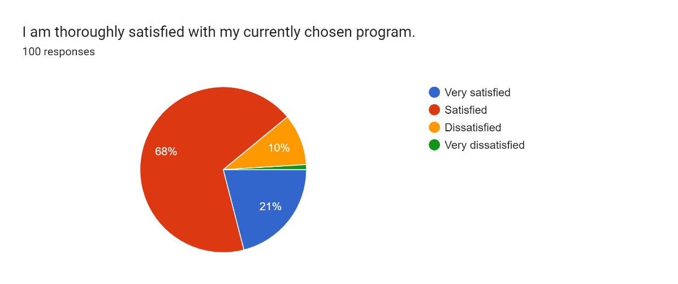Figure 1.1

The respondents were asked to provide answers to five statements using a 4-point Likert scale, where they indicated their level of satisfaction on a scale from 1 to 4. A rating of 1 signified the lowest satisfaction, equivalent to "very dissatisfied"; a rating of 2 indicated "dissatisfied"; a rating of 3 corresponded to "satisfied"; and a rating of 4 denoted the highest satisfaction or "very satisfied" based on the provided statements.

For the first statement, which assesses how satisfied respondents are with their currently chosen program, 68 respondents chose '3,' indicating satisfaction with their chosen program. Additionally, 21 respondents selected '4,' signifying that they are very satisfied with their program. Meanwhile, 10 respondents expressed dissatisfaction, choosing a rating of '2,' and one respondent indicated being very dissatisfied with their current program. The above results indicate that the majority of the respondents are satisfied with their chosen program.

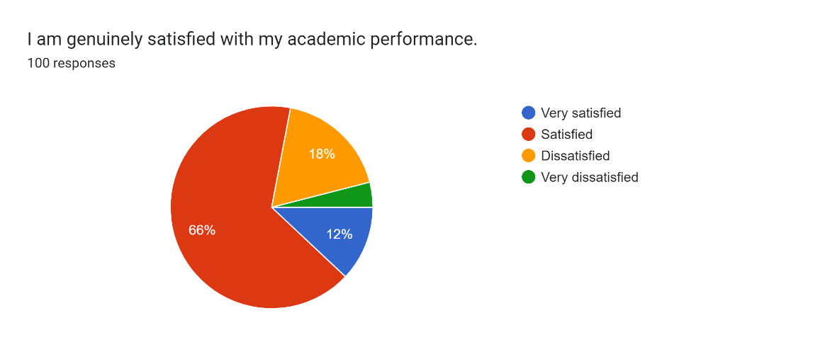

Figure 1.2

In response to the second statement, 'I am genuinely satisfied with my academic performance,' 66 respondents chose '3,' indicating satisfaction with their academic performance. Eighteen respondents selected '2,' expressing dissatisfaction. Conversely, 12 respondents indicated being very satisfied with their academic performance. In contrast, only four respondents reported being very dissatisfied with their academic performance. The results show that the majority, or more than half, of the 100 respondents are satisfied with their academic performance.

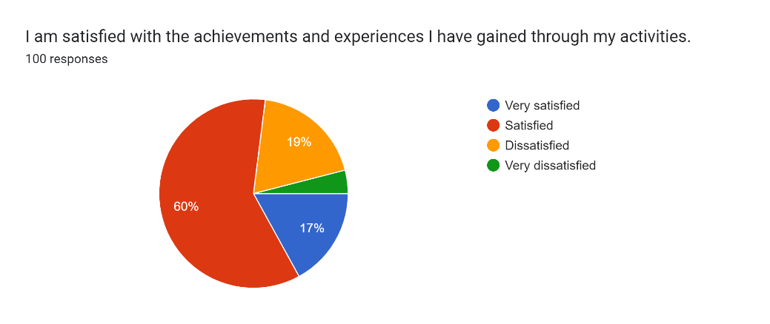

Figure 1.3

For the third statement, which assesses respondents' satisfaction with the achievements and experiences gained through their activities, the majority—60 respondents—answered '3,' expressing satisfaction. In contrast, 19 respondents answered '2,' indicating dissatisfaction. Seventeen respondents chose '4,' signifying that they were very satisfied with their achievements and experiences. Only four respondents selected '1,' expressing strong dissatisfaction with what they have gained through their academic activities.

Forms response chart. Question title: I am content with the progress I&apos;ve made in my academic journey.
. Number of responses: 100 responses.

Figure 1.4

In response to the fourth statement, 'I am content with the progress I've made in my academic journey,' 58 respondents chose '3,' indicating satisfaction with their progress, while 24 respondents selected '2,' expressing dissatisfaction with their academic journey. Thirteen respondents opted for '4,' indicating strong satisfaction with their progress. In contrast, 24 respondents strongly expressed their dissatisfaction with their academic journey by choosing '1'. This concludes that a total of 71 respondents are satisfied with the progress they've made in their academic journey, with 58 respondents choosing '3' and 13 respondents selecting '4' in response to the statement.

Forms response chart. Question title: I am satisfied with the achievements from my extracurricular activities.
. Number of responses: 100 responses.

Figure 1.5

In the fifth and last statement, 'I am satisfied with the achievements from my extracurricular activities,' 58 respondents chose '3,' indicating satisfaction with their achievements, in contrast to the 23 respondents who chose '2,' indicating dissatisfaction. Meanwhile, 16 respondents chose '4,' expressing strong satisfaction, in contrast to the 3 respondents who expressed strong dissatisfaction with the achievements from their extracurricular activities. In conclusion, a total of 74 respondents are satisfied with their achievements from extracurricular activities, with 58 respondents choosing '3' and 16 respondents selecting '4' in response to the statement.

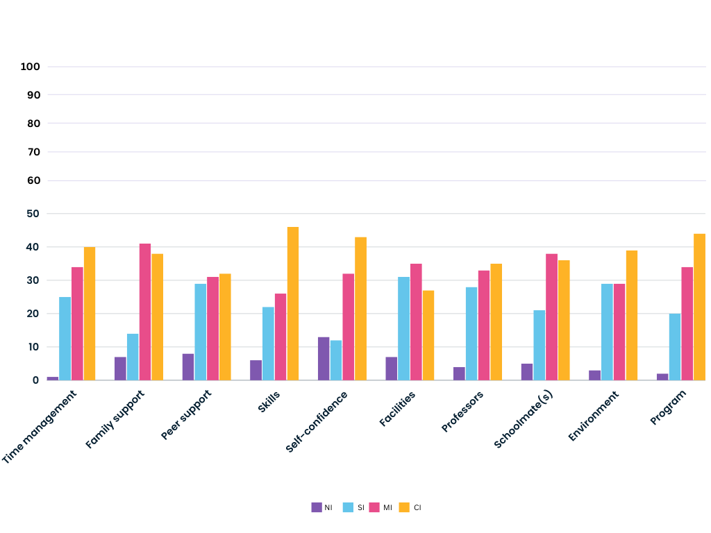**Figure 2: Factors Influencing Academic Performance**

Figure 2 illustrates the information gathered and analyzed by the researchers based on respondents' perceptions of how various people or things influence academic performance using Likert-like scale ratings. In this scale, NI represents not influential, SI represents slightly influential, MI represents moderately influential, and CI represents completely influential.

After analyzing the data from 100 respondents, the study revealed that 'Family support' is the most influential factor. Family support refers to the emotional, practical, and sometimes financial assistance that family members provide to one another. It is complex and multifaceted, involving a combination of emotional, financial, and educational support. Notably, it emerged as the most selected influential factor, with 79 respondents indicating that it is moderately to completely influential on their academic performance. This is followed by the "Program," selected by a total of 78 respondents who indicated a moderate to complete level of influence. According to 75 respondents, 'self-confidence,' which refers to a person's belief in their own abilities, skills, and judgment, is also moderately to completely influential in one's academic performance.

"Time management" and "schoolmate(s)" are each considered influential by 74 respondents, indicating that how individuals manage their time and interact with their schoolmates can impact their performance in school. Seventy-two respondents believe that 'skills,' which pertain to the abilities or competencies that individuals acquire through training, practice, or experience, are also considered influential in one's academic performance. In the context of academic achievement, skills play an instrumental role in shaping how individuals’ approach, engage with, and excel in academic endeavors. The acquisition and development of diverse skills contribute to a well-rounded and successful academic performance.

Sixty-eight respondents deemed 'professors' and 'environment' influential, indicating that both individual professor involvement and the overall learning environment impact academic performance. In the context of academics, 'peer support,' which involves students helping and supporting each other in their learning journey, is deemed influential by 63 respondents. "Facilities" were considered influential in academic performance by only 62 respondents, making it the least impactful factor according to the responses of 100 participants.

**Chapter 5   
Summary of findings, Conclusions,   
and Recommendations**

This chapter concludes the study by providing an overview of the findings, conclusions, and recommendations proposed by the researchers. It is organized into four sections. The initial section contributes to a comprehensive summary of the research, followed by a summary of the findings. Subsequently, the study's conclusions are outlined, followed by recommendations that must be stated in this chapter. The recommendations typically direct the reader to conduct further research on specific areas related to the topic.

Specifically, the study sought answers to the following:

1. What is the demographic profile of the respondents?
2. How does the chosen program affect the academic performances of first-year college students?
3. What are the possible outcomes when the chosen program aligns with one's career path?
4. To what degree does satisfaction with the chosen program correlate with academic performance in the first-year students?
5. To what extent is the chosen program the most influential factor among others in the student's academic performance?

**Summary of Findings**

Based on the gathered data and the interpretation of the collected information, the researchers derived the following findings:

**1. Demographic Profile of the Respondents**

1.2 The respondents comprised 70% males and 30% females, indicating that males constitute the majority of the respondents.

1.3 Out of the 100 respondents, 59% were from BSIS, 17% from BSIT, 15% from BSEMC, and the remaining 9% were from BSCS.

**2. How does the chosen program affect the academic performance of first-year college students?**

To investigate how the chosen program affects the academic performance of first-year college students, respondents were initially asked whether they believed a student's chosen program could impact academic performance. Only the responses of those who answered 'yes' were included, comprising 80 respondents or 80% of the total number. Subsequently, out of these 80 respondents, they were asked to select the possible effects they believed could impact students when they were unable to pursue their preferred program. Sixty-seven respondents chose 'lack of motivation,' indicating it was the most selected possible effect among the options. This was followed by 'poor academic performance,' chosen by 52 respondents, and 'develops self-doubt,' selected by 45 respondents. Only 13 respondents chose 'enhance self-confidence,' making it the least likely effect when a student was unable to pursue their preferred program.

**3. The possible outcomes when the chosen program aligns with one's career path**

Findings revealed that 85 respondents believe that choosing a program in line with their career path develops self-confidence. Additionally, 83 respondents indicated that it can improve students' achievements, and 78 respondents stated that it enhances academic performance. In contrast, only seven respondents think that there will be a decrease in motivation and engagement, along with the development of family issues.

**4. The degree of satisfaction with the chosen program that correlates with the academic performance of first-year students**

To assess the degree of satisfaction among students with their chosen programs, various statements related to this were presented in the Likert scale questions. In the first statement, 'I am thoroughly satisfied with my currently chosen program,' the results showed that 89% of the 100 respondents expressed satisfaction with their current chosen program.

In the subsequent statement, 'I am genuinely satisfied with my academic performance,' 78% of the total respondents indicated satisfaction with their academic performance. Moving to the fourth statement, 'I am content with the progress I've made in my academic journey,' a total of 71 respondents expressed satisfaction with the progress they've made, with 58 choosing '3' and 13 selecting '4' in response to the statement.

**5. Extent of the chosen program as an influential factor among other factors in the student's academic performance**

Among the 100 respondents, 'Family support' emerged as the most influential factor, with 79 participants indicating that it is moderately to completely influential on their academic performance. Following closely is the 'Program,' selected by a total of 78 respondents who indicated a moderate to complete level of influence. In contrast, only 62 respondents considered 'Facilities' to be influential in academic performance, making it the least impactful factor according to the responses of the 100 participants. According to the findings, the program ranked second among the various influential factors, following closely behind 'Family support'.

**Conclusion**

Following a sequence of tests, analyses, and evaluations performed on the collected facts and data, along with extensive studies, the researchers reached the subsequent conclusions:

1. According to the survey findings, the researchers identified a positive relationship between a student's academic performance and their choice of program. Most respondents believe that selecting a program can influence academic performance. The collected data reveals that the majority of respondents' programs are not their initial or preferred choices. As the frequency of those with a non-preferred program choice increase, the number of respondents acknowledging the impact of program selection on academic performance also rises. This indicates a positive correlation, suggesting that both variables vary in the same direction.
2. Based on the survey, which focuses on challenges students might encounter when their program deviates from their desired career path, the majority of participants believe that a lack of motivation is the most likely factor to negatively impact a student's academic performance and accomplishments. Subsequently, poor academic performance and the emergence of self-doubt rank as the following factors, indicating that the majority of participants view these potential consequences in a negative light.
3. According to the survey on effective solutions to help first-year college students overcome difficulties in their career paths, the researchers concluded that the majority of respondents are convinced that the most viable solution is skills development. 'Skills development' refers to the acquisition, improvement, and refinement of a diverse range of abilities essential in both academic and professional contexts. Investing in skills development proves invaluable for students, providing them with the necessary tools to navigate and overcome challenges in their career journeys. Furthermore, participants express the view that setting clear goals and being responsible for one's academic journey is beneficial.
4. According to the collected data, the majority of the respondents believe that choosing a program that is in line with their career path will develop one's of self-confidence and improvement in academic achievement and performance.
5. The collected data from Likert-scale survey questions indicates that most respondents’ express satisfaction with both their selected program and academic performance, along with the accomplishments derived from it. Despite it not being their initial preference, the majority of individuals are content with the advancements and achievements attained throughout their academic journey.
6. As per the survey exploring the factors affecting students' academic performance, the researchers determined that a significant portion of respondents holds the view that 'skills' is the primary influential factor. The factor 'Program' closely follows, ranking second in terms of its impact on academic performance, with more than half of the respondents considering it influential. The researchers reached the conclusion that respondents believe the program has a significant influence on academic performance.

**Recommendation**

After thoroughly examining the survey findings and the significant correlations identified between program selection and academic performance, several recommendations emerge to enhance the academic experiences of first-year college students. These recommendations stem from the understanding derived from the survey data and seek to tackle the issues emphasized in the research.

Career Guidance and Counseling Programs: Recognizing the impact of program selection on academic performance, institutions should establish effective career guidance and counseling initiatives. These programs can assist students in making well-informed decisions about their chosen programs by expanding access to comprehensive career-related information, workshops, and career fairs. By granting students access to resources and guidance from professionals during the decision-making process, institutions can help them make more informed program selections that align with their career objectives, potentially enhancing their academic performance.

Implement Program-specific Academic Support Initiatives: To address the identified challenges associated with program deviations from desired career paths, institutions should consider developing tailored academic support initiatives for students facing such circumstances. This could encompass the introduction of targeted mentoring programs, the provision of additional tutoring services, and the creation of specialized study groups crafted to fulfill the unique needs of students in particular programs.

Skills Development Integration: Considering the recognized significance of skill development in overcoming career-related challenges, educational institutions should integrate skill-building components into their curricula. This proactive approach ensures that students possess a versatile set of skills, enhancing their ability to navigate challenges and succeed academically.

Monitor and Adapt Career-related Networks: Building on the importance of networks and connections in career development, institutions should consistently monitor and adapt their mentorship programs and career-related clubs. It is crucial to guarantee that these resources remain accessible and adaptable to the evolving needs of students, contributing to the creation of a supportive environment conducive to both academic and career success.

Conduct Ongoing Research and Evaluation: Due to the ever-changing nature of career decision-making, institutions should actively conduct continuous research to investigate additional factors influencing program selection and academic performance. Long-term studies can offer valuable insights into the sustained effects of interventions, enabling a continuous process of improvement and refinement of strategies.

Through the adoption of these suggestions, institutions can play a role in creating a more knowledgeable, supportive, and favorable environment for first-year college students. This, in turn, will nurture academic success and alignment with their selected career paths.

**BIBLIOGRAPHY**